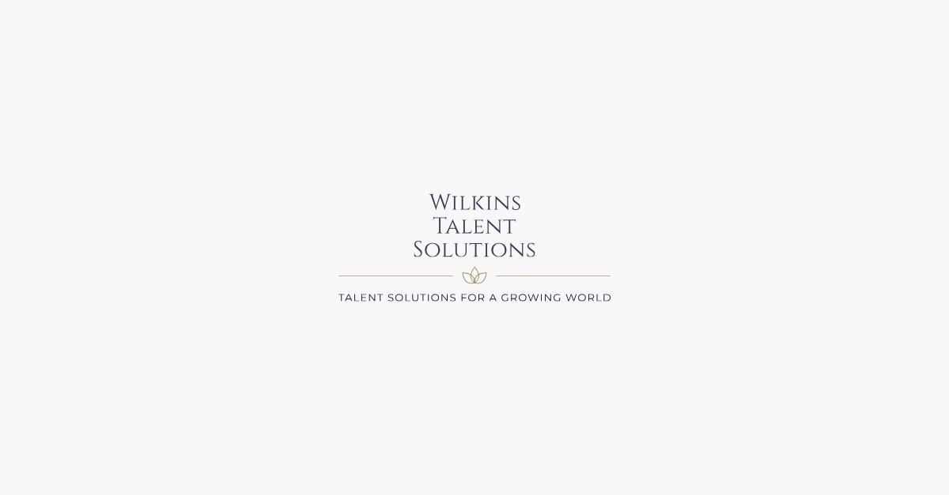

Anti-Bribery and Anti-Corruption Policy

1. ANTI-BRIBERY AND ANTI-CORRUPTION POLICY STATEMENT

In the spirit of transparency and honesty, we are committed to conduct all of our business in an honest and ethical manner. We take a zero- tolerance approach to bribery and corruption and are committed to acting professionally, fairly, and with integrity in all our business dealings and relationships.
2. WHO MUST COMPLY WITH THIS POLICY?

This policy applies to all persons working for us or on our behalf in any capacity, including employees at all levels, directors, officers, agency workers, seconded workers, volunteers, interns, agents, contractors, external consultants, thirdparty representatives and business partners.
3. WHAT IS BRIBERY?

A “Bribe” means a financial or other inducement or reward for action which is illegal, unethical, a breach of trust, or improper in any way. Bribes can take the form of money, kickback, gifts, loans, fees, hospitality, services, discounts, the award of a contract, or any other commercial or personal advantage or benefit.
“Bribery” includes offering, promising, giving, accepting or seeking a bribe.
All forms of Bribery are strictly prohibited. If you are unsure about whether a particular act constitutes bribery, raise it with Kate John at kate@katejohnassociates.co.uk.
Specifically, you must not:

• give or offer any payment, gift, hospitality or other benefit in the expectation that a business advantage will be received in return, or to reward any business received;
• accept any offer from a third party that you know or suspect is made with the expectation that we will provide a business advantage for them or anyone else;
• give or offer any payment (sometimes called a facilitation payment) to a government official in any country to facilitate or speed up a routine or necessary procedure (even if these payments are common in certain countries); or
• threaten or retaliate against another person who has refused to offer or accept a bribe or who has raised concerns about possible bribery or corruption.
4. GIFTS AND HOSPITALITY

This policy does not prohibit giving or accepting reasonable and appropriate hospitality (including meals, drinks, or other activities) for legitimate purposes such as building relationships, maintaining our image or reputation, or marketing our products and services.
Gifts must be of an appropriate type and value depending on the circumstances and taking account of the reason for the gift. In general, the gifts should not exceed 50 GBP/EUR/USD.
Gifts or hospitality will be inappropriate if they are unduly lavish or extravagant, or could be seen as an inducement or reward for any preferential treatment (for example, during contractual negotiations or a tender process).
Gifts must not include cash or be given in secret. Gifts must be given in the company’s name, not your name.
Cash equivalent (such as vouchers) must not be given, except when given by Marketing as part of an approved promotional campaign involving chance (in other words, the recipients must be selected at random).
Promotional gifts of low value such as pens, bags, shirts, hats, or other low value branded articles may be given to or accepted from existing customers, suppliers and business partners.
5. RECORD KEEPING

You must declare and keep a written record of all hospitality or gifts given or received, which you can do by always submitting these as expense claims (such as for hospitality) or through approved vendors (such as
through our procurement process for marketing spend). You must also submit all expense claims relating to hospitality, gifts or payments to third parties in accordance with our expenses policy and record the reason for expenditure.
All accounts, invoices, and other records relating to dealings with third parties including suppliers and customers should be prepared with strict accuracy and completeness. Accounts must not be kept “off-book” to facilitate or conceal improper payments.
6. WHO IS RESPONSIBLE FOR THIS POLICY?

Anneka Wilkins has overall responsibility for ensuring this policy complies with our legal and ethical obligations, and that all those under our control comply with it and can be reached at anneka@wilkinstalentsolutions.co.uk
Anneka Wilkins has primary responsibility for implementing this policy, monitoring its use and effectiveness, dealing with any queries about it, and reviewing internal control systems and procedures to ensure they are effective in countering bribery and corruption.
This policy will be reviewed regularly and we may amend it at any time to update with best practices and processes.
7. YOUR COMPLIANCE WITH THIS POLICY

You must ensure that you read, understand and comply with this policy.

Preventing, detecting, and reporting bribery in any part of our business or supply chains is the responsibility of those working for us or under our control. You are required to avoid any activity that might lead to, or suggest, a breach of this policy.
8. HOW AND WHEN TO NOTIFY IN CASE OF NON-COMPLIANCE

If you are offered a bribe, or are asked to make one, or if you suspect that any bribery, corruption or other breach of this policy has occurred or may occur in the future, you must notify your manager as soon as possible.
You are encouraged to raise concerns about any issue or suspicion of bribery in any parts of our business or supply chains at the earliest possible stage.
If you are unsure about whether a particular act constitutes any of the various forms of bribery, raise it with your manager at the email above.
We aim to encourage openness and will support anyone who raises genuine concerns in good faith under this policy, even if they turn out to be mistaken. We are committed to ensuring no one suffers any detrimental treatment as a result of reporting in good faith their suspicion that bribery of whatever form is or may be taking place in any part of our own business or in any of our supply chains. Detrimental treatment includes dismissal, disciplinary action, threats or other unfavourable treatment connected with raising a concern. If you believe that you have suffered any such treatment, you should inform your manager immediately.
9. COMMUNICATION AND AWARENESS OF THIS POLICY

Training on this policy, and on the risk our business faces from bribery, forms part of the regular training for our employees.
Our commitment to addressing issues of bribery in our business and supply chains should be communicated to all suppliers, contractors and business partners at the outset of our business relationship with them and reinforced as appropriate thereafter.
10. BREACHES OF THIS POLICY

Any employee who breaches this policy may face disciplinary action, which could result in dismissal for misconduct or gross misconduct.
We may terminate our relationship with other individuals and organisations working on our behalf if they breach this policy.

